ADEPT FURNITURES & INTERIORS

*FOR YOUR HIGHLY SKILLED AND PROFFESSIONAL PRODUCTS*

ALWAYS EVOLVING

# COMPANY FROFILE

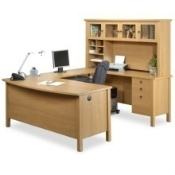 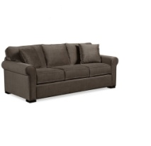 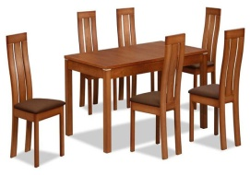 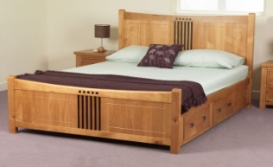

_________________________________________________

# WITH US, IT IS A DONE DEAL!!!



**CONTACT DETAILS:**

**CELL: 0979 203967/ 0974 324496**

**Email:** [adeptfurnitures@yahoo.com](mailto:adeptfurnitures@yahoo.com)

**Plot 4495 Provident House 8th Floor Cairo Road**

**P.O Box 37275, Lusaka**

***Company Overview***

*Adept Furnitures and Interiors is a professionally managed entity which aims at changing how Zambians view locally made products. It is in pursuit of this ultimate goal that makes us value our clients and ensure customer satisfactions at all costs.*

*We are an indigenous Zambian company, which has provided employment to a number of people and intend to continue doing so, even as we grows from one strength to strength.*

***Company Information and Contact Details***

***Company Name: Adept Furnitures and Interiors Limited***

***Registration number: 120160008473***

***Tpin Number: 1004060663***

***Serial Number: 1032687***

***Physical Address: Plot 4495 Provident House 8th Floor Cairo Rd***

***Mailing Address: P.O BOX* 37275**

***CONTACTS***

***0979 203969***

[***adeptfurnitures@yahoo.com***](mailto:adeptfurnitures@yahoo.com)

***General Business Activities****: Adept Furnitures and Interiors has been established as a company that deals in wood related products. Our traditional business model is based on manufacturing a wide range of furniture and related products in Zambia. The company also does however, import products from other parts of the world for a wider selection to our esteemed clients. Our qualified staff, which comprises of highly trained locals and expatriates, has given an edge over our competitors.*

***Company Strategy***

* ***Purpose:*** *To be a leader in the manufacturing of all kinds of furniture in Zambia and other countries.*
* ***Vision:*** *To provide quality services that exceeds the expectations of our esteemed customers.*
* ***Mission statement:*** *To build long term relationships with our esteemed customers and provide exceptional customer services by pursuing business through innovation and advanced technology.*
* ***Core values:*** *•We believe in treating our customers with respect and faith. •We grow through creativity, invention and innovation. •We integrate honesty, integrity and business ethics into all aspects of our business functioning.*
* ***Goals:*** *Customer satisfaction at all costs, is our ultimate goal. •Regional expansion in the field of Furniture Manufacturing and Supplying. •Increase the assets and investments of the company to support the development of services. •To build a good reputation in the field of Furniture Manufacturing and Supplying and become a key player in the industry.*

***Scope of Work***

*Adept Furnitures and Interiors manufactures and supplies a wide range of products ranging from office furniture, office Partitions, house hold furniture such as Sofa’s, Kitchen Units, Beds, T.V stands, Dressing Mirrors etc. We also supply school Desks and Study Tables.*

